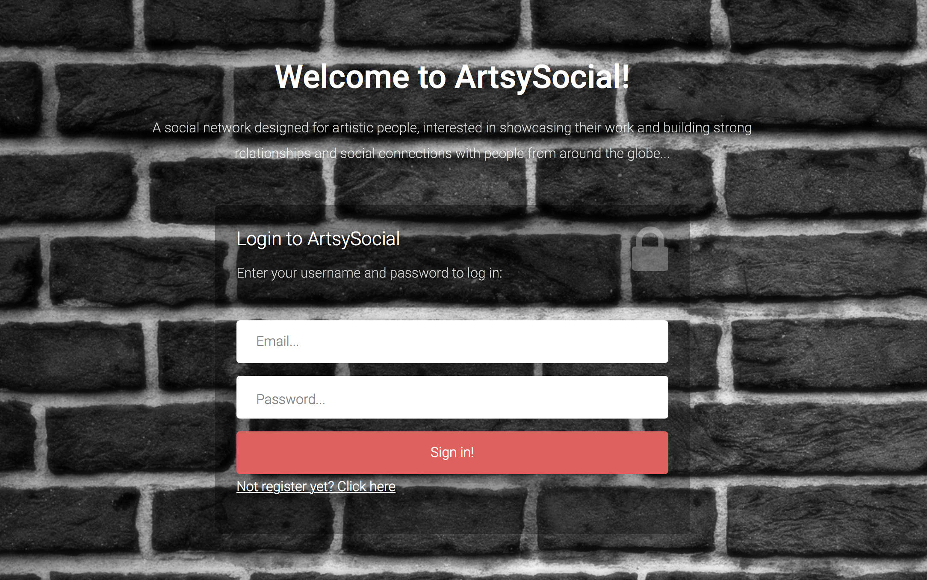

REPORT

Second Coursework in the Advanced Web Technologies

Phoebe Kalatzi | 40127093 | 30th November 2016

1

Table of Contents

- Introduction…………………………..………………………………………………….……........3

- Design Section…………………………….………………………………………………….......4

- Enhancements………………………………………………………….………………………....6

- Critical Evaluation……………………………………………………………..………........8

- Personal Evaluation…………………………………………………………………..…....10

- Summary of Resources and References…….………………..........11

1. Introduction

“Artsy-Social” is a micro social network developed for talented people that simply want to showcase their creative work pieces as well as to form social connections with people from similar backgrounds. The concept of Artsy-Social was inspired by existing popular social media platforms such as Twitter, Facebook, LinkeIn and it was an effort to design a user-friendly platform that would support and offer known to users features but would be also benefited by some unique implementations, no previously attempted. Its brand name derives from the words, “artsy” which is a slang word used to describe people involved in artistic endeavours, and the word “social”.
Currently this web application gives users the ability to create new accounts and then use their personal credentials to log in and access the full content of the application. ArtsySocial was designed to essentially give users the ability to showcase their personal portfolios online and share them along with other personal information with the rest of the world. At this point, this facility has been developed only as a prototype to demonstrate its functionality; however there are future plans to develop it as a fully functional framework.
The main feature, ‘ArtsySocial’ currently provides is a social media environment where only registered users have the ability to post messages in their personal stream feeds as well as querying other users’ profiles. The application also gives users the option to follow or unfollow people, which allows them to build social connections or in some cases even relationships. Although posted messages of users become immediately available in their personal profiles, in order for other users to be able to view a specific user’s posts in their personal post feeds they are required to be following that particular user. In the case they are not following them they need to query specifically this user to view their stream feed.
2. Design Section

Folder and File Structure

Bellow there are the main elements of my structure. Subfolders and files that seemed unnecessary for my application’s operation have not been included.

~/src (main folder containing the source code of the app)
|-- index.py (file used to run the application)
|-- models.py (file that configures my database schema)
|-- forms.py (file that handles my forms and their validations)
|-- requirements.txt (file containing my app’s dependencies)
|__ /etc
|--defaults.cfg (file containing my configuration parameters)
|__ /static (folder containing my static files)
|__ /css
|-- custom.css (my custom CSS file)
|-- freelancer.css (freelancer’s bootstrap template css)
|-- freelancer.min.css (freelancer’s bootstrap template css)

|__ /form-3 (folder containing all the necessary subfolders and static files for my bootstrap login and register templates)
|__ /img (folder containing images used throughout my app)
|__ /js (folder containing all my JavaScript files)
|__/uploads (folder containing subfolders with my portfolio images)
|__/infographics
|__/photography
|__ /templates (folder containing all my templates)
|-- 404.html (template for the 404 error page)
|-- index.html (template for the layout of my login and register pages)
|-- login.html (template for my login page)
|-- register.html (template for my register page)
|-- layout.html (template for the layout of my portfolio and about pages)
|-- layout2.html (template for the layout of the post-feed page. It is actually a copy of the layout.html)
|-- macros.html (template with referencing elements to automate certain steps and speed up the development process)
|-- portfolio.html (template for the portfolio page)
|-- about.html (template for the about page)
|-- stream.html (template for the personal post feed section)
|-- user-stream.html (template for the post feed section of other users)
|-- post.html (template for the post message section)
|__ /var
|--loggingapp.log (file that logs user actions throughout my app)
|--updated-social.db (my database schema)

3. Enhancements

ArtsySocial is a micro social network website that currently offers users a few of the most common features of other current social media platforms, however there are many aspects of it that could definitely benefit of further developments and general enhancements. Some of these were initially in the scope of this coursework but due to the complexity of some other implementations I integrated into the project, they were put on hold.

These include the following:

- Login via Other services: Since the application is a micro social network, it could offer more interactive options to users in the future, such as the ability to login via their facebook, gmail or another one of their existing accounts.
- Merge with LinkedIn: Since ArtsySocial is a professional network it could provide a ‘linkedIn’ merge feature so that users could link it to their linkedIn accounts and enhance their network connections.
- Activation Email: During the registration process an auto-generated email could be sent to the user to activate their account.
- Reset Password: A ‘forgot password’ link could be added in the login screen so that users would be able to reset their passwords and retrieve their accounts in case they had forgotten their login credentials.
- Admin Account: There should be an admin account to perform administrative tasks such as content management.
- Translation: One of my first thoughts for this coursework was to integrate a translation service into the application since social networks are normally accessed by several users from around the world, however this was also put on hold due to time restrictions.
- Test Scripts: One major enhancement to the application would be to develop some test scripts to ensure that it is functioning properly.
- Search Field: One of my initial goals for this application was to provide a search bar at the top navigation bar that would allow users to search for existing profiles based on the user’s username. At the moment, since the application is not a completed project, users can search for other profiles by typing the username of the user they would like to query into the actual URL. This is a bad practice example and puts major limitations on the application’s use, such as the requirement for users to know existing usernames in advance. An improvement to this idea would be for the search field to be an auto-populated field that would require even less user input.
- Rich Text fields for user statuses, so that people could get as creative as they wish.
- Upload an Avatar: Allowing users to upload their personal avatars.
- Profile Deactivation: Allowing users to delete their profiles.
- Uploading personal statuses, portfolio images: Similarly to the ability above to upload their personal avatars, users should also be able to upload and add their own images in their portfolio section as well as being able to save their personal details in their “About me” section. Unfortunately that was another sector that was affected by time limitations.

4. Critical evaluation

The goal for my second coursework was to design and implement a more ambitious project that would offer the user more interactive features, would extend the work completed in the labs and lastly that would cover areas where my first application was weak at or did not manage to cover at all. After recommendations made in the class and some personal investigation as well, I became very attracted to the idea of developing a social media web app since it is the perfect combination between using methods approached during our practical work and investigating practices and techniques far more advanced.
ArtsySocial is a social media prototype that handles user registration and personal data storage using the SQLITE database, which allows interactivity and multiple user access. It also supports interactive features between different users such as storing relationships or posts made from one user to be viewed by the other. Apart from the use of a database which was a missing feature from my first coursework there are some other additions as well that demonstrate the high level of complexity of this project. For example, during the user registration and login processes there are validations and conditions in place that perform data control and put limitations to the user input. Another thing I implemented in this coursework for the first time, was the division of the main .py file that starts my application into 3 different modules. This approach has proved to be a very useful technique as it provides better structure to my files and I am planning to adopt it for all my future implementations.
Contrary to my previous coursework, I focused more on the functionality of this web app and less on its appearance, however I did not ignore basic usability rules and managed to built a user friendly interface nonetheless. I also tried to improve areas already approached in the past such as the error handling mechanism. For my 404 error page, for which I have used a JavaScript effect to make it more fun and interactive, I managed to integrate it into my existing layout this time, keeping my main navigation bar in for more convenient user redirection. Another area I tried to improve in was my logging facility, which has been developed to record user actions throughout my application and also to store more informative logging messages I can go back to, in order to analyse user patterns and behaviours.
To sum up I believe that my application has managed to meet the requirements of this coursework by making appropriate use of routing and sensible URL hierarchy, ‘POST’ and ‘GET’ requests, redirects, flash messages as responses to user actions, custom error handling mechanism, static files, templates, sessions, logging configurations, encrypted data encryption using bpcrypt, data storage as well as data transports to and from the database. On the other hand I also believe that it has extended the work covered in this module and has investigated more complicated and ambitious implementations that require extensive research and a significant amount of personal time.

5. Personal evaluation

In my previous coursework I had stated that this module introduced me to some new concepts for the first time and that it seemed overwhelming at times. For example, Python, the Linux environment or the Github repository were all unknown areas for me and that, combined with the fact that I was also new to the MAC OS made me struggle several times and work harder to overcompensate. However during this project none of the above concerns ever occurred to me, which showed me how much confidence I have built using these frameworks and that all my hard work has actually paid off.

I remember saying that I was very frequently facing issues with the whitespaces within the Vim editor and Python’s lack of forgiveness and to be honest I still encountered a few instances of misplaced return statements or other similar commands, however I am now fully aware of how to locate the issue and fix it and that is what differentiates things from before. Another struggle of mine used to be Github and I would be lying if I said that I understand everything about it now, however I find myself being a lot more confident around it and familiar with its commands. In this project though my biggest challenge was time and that was not due to bad time management or not proper prioritisation of tasks on my part but because it was a very challenging project itself and the fact that there were not enough resources online was not very helpful either. Other challenges I faced included the
“socket.error: (32, 'Broken pipe')” error in my console which I had been struggling with also in my first coursework and unfortunately nothing I tried was able to fix it so far. Other challenges I faced had to do with unsuccessfully imported libraries or warnings in my console, which I managed to resolve using the user suggestions mentioned in the references below.

I am certain that there are countless things out there still left to discover, investigate and deploy and that there are going to be struggles, I also know that my second application is nowhere near perfect but I have to admit that I really enjoyed the process of creating it, it has truly triggered my passion for web development once again and I feel that during its implementation I came across many ideas and concepts I want to pursue in my future so for me it has been more than just another assignment.

- Summary of Resources and References

Online tools and resources:

- Wallpaper and all application’s images were downloaded from pixabay.com or google images after applying copyright free filters

- https://startbootstrap.com/template-overviews/freelancer/ Bootstrap template for my main layout

- http://azmind.com/demo/bootstrap-login-forms/ Bootstrap template for my login and register forms

- https://desktop.github.com To monitor my local code and perform file upload
commits to my master branch in Github

- http://www.tripwiremagazine.com/2010/02/9-funniest-javascript-effects.html For the JavaScript used in my 404.html page

- http://preview.freelogodesign.org/   To create the logo of my application

Other documentation from online tutorials and forums

- https://teamtreehouse.com/library/build-a-social-network-with-flask I completed this tutorial to build the most extensive and advanced features of my social network web app
- http://stackoverflow.com/questions/16309650/python-importerror-for-strptime-in-spyder-for-windows-7 To resolve the issue ImportError: Failed to import _strptime because the import lockis held by another thread
- http://stackoverflow.com/questions/40700268/how-to-custom-the-fields-in-flask-wtf-forms To apply custom attributes on my fields in flask-wtf-forms
- http://stackoverflow.com/questions/38079200/how-can-i-disable-extdeprecationwarning-for-external-libs-in-flask To get help with the extdeprecationwarning warnings for external libraries
- ‘http://stackoverflow.com/questions/154443/how-to-avoid-pyc-files’ To stop .pyc files from being created

